**CHAPTER 1. INTRODUCTION TO IoT**

The internet of things, or IoT, is a system of interrelated computing devices, mechanical and digital machines, objects, animals or people that are provided with unique identifiers (UIDs) and the ability to transfer data over a network without requiring human-to-human or human-to-computer interaction.

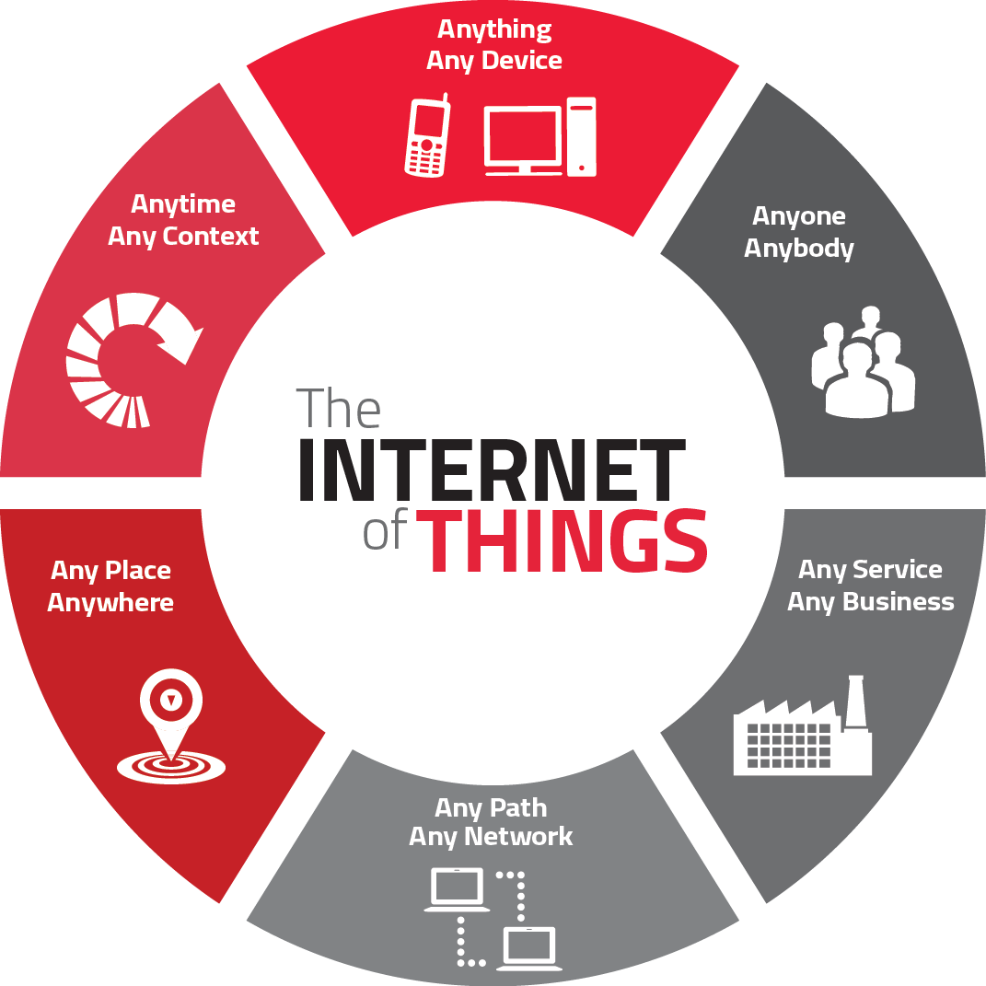

**Figure 1.1 Introduction to IoT**

**1.1 REQUIREMENTS FOR THE REAL WORLD PROBLEMS**

**1. Ability to monitor security** of substations, as well as real-time data on electrical use, and report exceptions so they can be addressed in a timely manner. Ability to solve problems across silos in a utility where IT, Operations and Security don’t talk to each other. Facilitate communications about what’s important.

**2**. **Any information you need from a device** in order to perform a particular action. Examples provided:

* Re-closer on the distribution side of a power line that gets hit by lightening can be closed, checked and reopened by machine after reading the information on the site.
* Measure temperature and flow of a pipeline to ensure everything is working as expected or be notified is variances outside the norm are seen.
* Solar back-up to devices that may have power or battery issues.

**3. Ability to know how to fix your garage door** because the sensor can tell the company what’s wrong and they can tell you how to fix it. B2B example - a biolab is not aware of the volume of enzymes their clients still had on hand. If client ran out, they’d have to put a project on hold for a week or two while more enzymes we made and shipped. They now put one of our devices on every enzyme container so they know which scientist is using which enzyme and when supply is running low. Real-time stock updates enable New biolab to optimize the supply chain for their clients.

**4. Communication, collaboration, cohesion and unification of various objects.**Becoming more convenient and connected with the devices we use everyday. How to collaborate with devices and work through technology.

**5. Streamlines efficiency and communication of information.**Sensors provide data all the time. Influences decisions by giving you real-time data. Sensors in stores and in manufacturing environments tell you exactly what’s going on and if something is out of the acceptable range you can correct it quickly. Emergence of smaller computers are enhancing communications. We’re taking commodity hardware and optimizing with sensors.

6**.** All technology starts as a novelty. Becomes a convenience. That’s where IoT is now. **Making it more convenient to control and monitor the 3D printer.** Not yet a pure utility (the end stage for a technology). Ultimately, going forward, things will be built with IoT as a core element, not a special feature. For us, the end point is the printer which can source content from the internet.

**7. Industrial internet** - **digitization can be applied to the decision making process.**Consumer and healthcare companies will have new apps with connected devices to help save lives and mitigate disasters (e.g., floods, earthquakes).

**8. All IoT solutions solve some problem** - some are smaller, some are bigger. It’s easy to make a lock to connect to the internet. We use cryptography, website and code so the lock doesn’t have to be connected to the internet. Our IoT is not connected to the internet, just the website. As such, the lock cannot be hacked.

**9. Simpler, less expensive home health monitoring** (e.g., scales, blood pressure) to prevent post-surgical events that require return visits to the hospital. Increase adoption and adherence to medication protocols. Opportunity to use data to predict what’s going to happen. Preventive and predictive healthcare.

**10**. **A** **connection between humans and computers.** Use Amazon Echo to get all his songs from Amazon Prime and play on demand. Links home management like garage door, lights and HVAC.

**11. Energy saving.** A lot of devices are left on overnight, or longer. Interact with buildings and homes to save energy.

**12. Health devices connected to Smartphone’s diagnose health conditions quickly.** You can take pictures and obtain diagnostics to share with health professionals around the world. Enables the collection and sharing of data in an affordable way. Allows inventors to think about use cases. Digitizes the power grid. Play with how energy is being served. Every device in your house will give you an energy profile. Enterprises will benefit from the digitization of devices and enable the next wave of digitization.

**13.** Know people that are in the building and **have visibility into what’s going on**. We monitor several thousand conference rooms at Microsoft’s campus to determine if they’re occupied, if A/V is working, what devices people are using, scheduling, booking. We collect data in the cloud to analyze uptime and failure rates. We proactively monitor to see what’s going on. We have statistics about room use and occupancy that will inform and influence the design of the conference rooms on Microsoft’s new campus. In homes, our hub connects all light switches, thermostats, keypads, security system and provides statistics to the cloud so the homeowner can view a dashboard to see how the home is being used. Occupancy use data. We’ll be able to use predictive analytics to make suggestions on how to change the real-time lighting, temp, etc. for your home. Many more touchpoints - switches, mobile phone, devices, reporting to the cloud versus a single thermostat (Nest) - provide more data for analysis.

**14. Changed the brand cycle.**It used to be 18 to 24 months. Now you must be monitoring social networks to hear what customers are saying and address their concerns or leverage what they are seeing as most beneficial. As John Chambers says, 40% of companies won’t exist in 10 years if they’re not listening to, and responding to the needs of, their customers.

**15. Asset management** - how to engage information to run control systems. Understand the health of the asset producing the work. Know the health and diagnostics of the machine to reduce down time and proactively provide maintenance. Ability to tie the supply chain into the process and provide information back to manufacturing thus reducing costs and expense.

**16. Manufacturers using crowd sourcing to build out their manufacturing floor.** Consumer wireless routers are only secure for a couple of years. Consumer products have a short life expectancy with consumers. Whereas industrial companies need to have an ongoing relationship with their customers since they have service contract and the products often need ongoing service. In healthcare alone IoT has already made incredible contributions saving lives, giving doctors the ability to see a spectrum of health conditions across a large number of people. It will enable more self-care by patients. Clinical trials are now being based on data received from IoT devices thus accelerating time to market. Industrial is incredibly influential because of the buy in from so many big players like IBM, Cisco and GE.

**17. Enables people to try a new approach.** Automate and control things remotely in ways you couldn’t before. Opportunities differ by industry but every industry has many opportunities.

**18.** We’re at the very early stages but making progress every day. **Getting basic, real-time visibility into places where we haven’t had it before.** For example, we can see a pipeline every half mile and look at KPIs for variances rather than have a human out driving the line and taking measurements. We’ve figured out how to put predictive diagnostics in place. We’re creating a digital twin on the product based on historical performance so we can identify potential needs. IoT provides visibility and reliability where we’ve never had it in the past.

**19. Mundane things.** We have a school district in Florida with wi-fi clocks. We save them time and money, and ensure the clocks are accurate, after power outages and daylight saving time changes. Student athletes at a university are calling the help desk regarding how to get their personal devices to connect with the scales at the athletic center so the trainers can track biometrics. Also in universities, next generation professors need to connect to the Apple TVs for their presentations and improving basic efficiencies.

**20. Specific use cases:**

* Implantable healthcare devices implanted subcutaneously to monitor vital signs for diagnostic follow-up. Communicate vitals to base station to app in the cloud. Depending on the situation, the correct people are notified of the vital signs. using communications logic, secure data following HIPPA laws escalating notifications as dictated by the data or situation.
* Dam holding water has myriad sensors monitoring the water level and the aperture of the gates. Preset threshold communications logic kicks in. Looks at the schedule to see who’s on staff. If the right people are on staff, they respond to the action required. If not, the communications are escalated based on the communications policy logic and sensor information. Scale and extreme impact of the decision that the logic needs to make. Do we need to evacuate? Zones of evacuation are identified based on what the sensors are saying and home can receive phone calls at 2:00 am if evacuation is called for.
* Innocuous business decisions - making dumb devices smarter. Badge for new employee or visitor provides access control, an active directory and a begins a set of initiatives to (e.g., assignment of office, desk, computer, insurance) and business security. Profile of the person is continually updated based on the last use of their badge so we know where they are in the event you need to communicate with them because you need their expertise in an adjacent area, or in the event of a building emergency.
* Assembly lines with complex machinery coming down the line. Numerous tests are run with data indicating whether an item/action passes or fails. If it fails, here are the people who must be notified to deal with it. Depending on the failure, the communication may, or may not, need to be escalated.

**1.2 APPLICATIONS OF INTERNET OF THINGS**

### Smart Home:

Smart Home clearly stands out, ranking as highest Internet of Things application on all measured channels. More than 60,000 people currently search for the term “Smart Home” each month. This is not a surprise. The IoT Analytics company database for Smart Home includes 256 companies and startups. More companies are active in smart home than any other application in the field of IoT. The total amount of funding for Smart Home startups currently exceeds $2.5bn. This list includes prominent startup names such as Nest or AlertMe as well as a number of multinational corporations like Philips, Haier, or Belkin.

### 2.   Wearables:

Wearable remains a hot topic too. As consumers await the release of Apple’s new smart watch in April 2015, there are plenty of other wearable innovations to be excited about: like the Sony Smart B Trainer, Look See bracelet. Of all the IoT startups, wearable maker Jawbone is probably the one with the biggest funding to date. It stands at more than half a billion dollars!

### 3.   Smart City:

Smart city spans a wide variety of use cases, from traffic management to water distribution, to waste management, urban security and environmental monitoring. Its popularity is fueled by the fact that many Smart City solutions promise to alleviate real pains of people living in cities these days. IoT solutions in the area of Smart City solve traffic congestion problems, reduce noise and pollution and help make cities safer.

### 4.     Smart grids:

Smart grids is a special one. A future smart grid promises to use information about the behaviors of electricity suppliers and consumers in an automated fashion to improve the efficiency, reliability, and economics of electricity. 41,000 monthly Google searches highlights the concept’s popularity. However, the lack of tweets (Just 100 per month) shows

### 5.    Industrial internet:

The industrial internet is also one of the special Internet of Things applications. While many market researches such as Gartner or Cisco see the industrial internet as the IoT concept with the highest overall potential, its popularity currently doesn’t reach the masses like smart home or wearable do. The industrial internet however has a lot going for it. The industrial internet gets the biggest push of people on Twitter (~1,700 tweets per month) compared to other non-consumer-oriented IoT concepts.

### 6.   Connected car:

The connected car is coming up slowly. Owing to the fact that the development cycles in the automotive industry typically take 2-4 years, we haven’t seen much buzz around the connected car yet. But it seems we are getting there. Most large auto makers as well as some brave startups are working on connected car solutions.  And if the BMWs and Fords of this world don’t present the next generation internet connected car soon, other well-known giants will: Google, Microsoft, and Apple have all announced connected car platforms.

### 7.   Connected Health (Digital health/Tele-health/Telemedicine):

Connected health remains the sleeping giant of the Internet of Things applications. The concept of a connected health care system and smart medical devices bears enormous potential, not just for companies also for the well-being of people in general. Yet, Connected Health has not reached the masses yet. Prominent use cases and large-scale startup successes are still to be seen. Might 2015 bring the breakthrough?

### 8.   Smart retail:

Proximity-based advertising as a subset of smart retail is starting to take off. But the popularity ranking shows that it is still a niche segment. One LinkedIn post per month is nothing compared to 430 for smart home.

### 9.    Smart supply chain:

Supply chains have been getting smarter for some years already. Solutions for tracking goods while they are on the road, or getting suppliers to exchange inventory information have been on the market for years. So while it is perfectly logic that the topic will get a new push with the Internet of Things, it seems that so far its popularity remains limited.

### 10.   Smart farming:

Smart farming is an often overlooked business-case for the internet of Things because it does not really fit into the well-known categories such as health, mobility, or industrial. However, due to the remoteness of farming operations and the large number of livestock that could be monitored the Internet of Things could revolutionize the way farmers work. But this idea has not yet reached large-scale attention. Nevertheless, one of the Internet of Things applications that should not be underestimated. Smart farming will become the important application field in the predominantly agricultural-product exporting countries.